Estimated Monthly Costs

1. \*Amazon EC2\*

T4g.nano (5 instances, On-Demand): - Total: $7.67

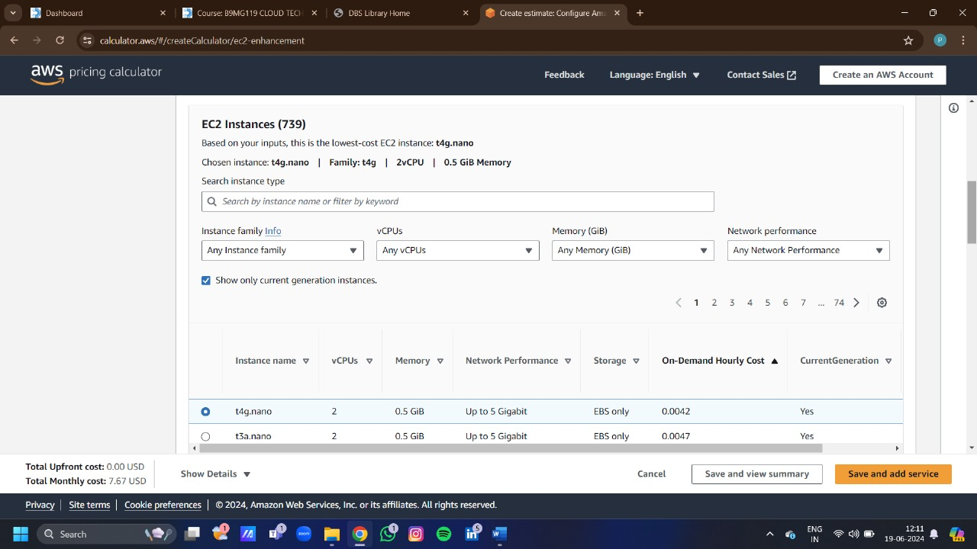

2. \*Amazon RDS\*

- db.t3.medium: $18.88 (assuming $0.026 per hour)

- Storage: $12.50 (assuming $0.125 per GB)

- Backup storage: $12

- Total: $1.14

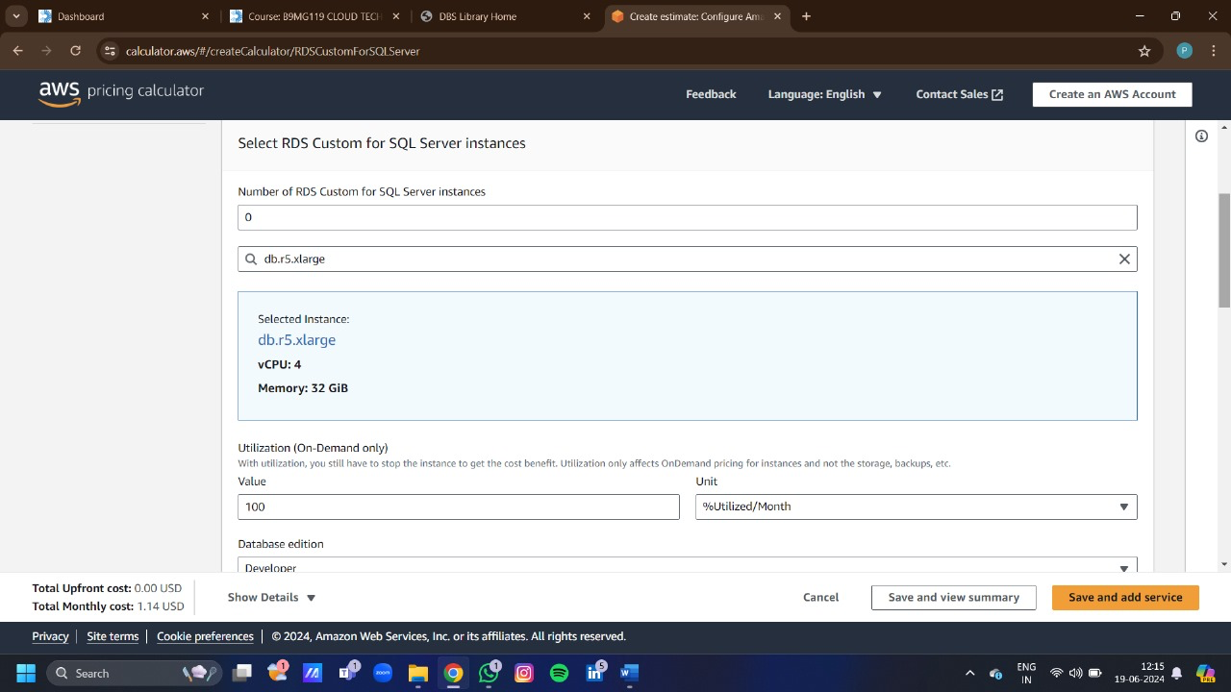

3. \*Amazon S3\*

- Storage: $12 (assuming $0.023 per GB)

- Data transfer: $4 (assuming $0.09 per GB)

- Total: $0.71

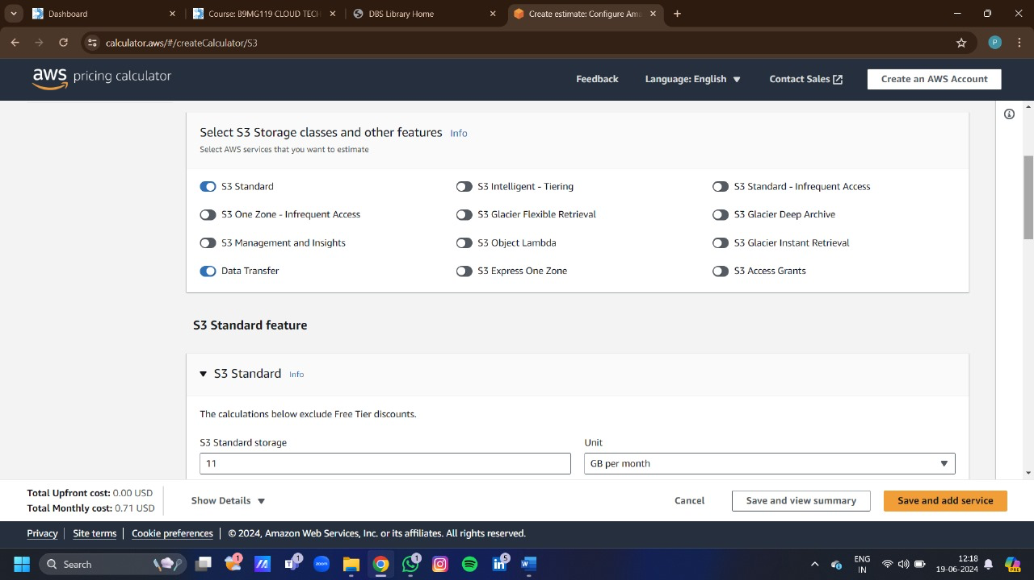

4. \*AWS Secrets Manager\*

- Number of secrets: $5.00 (assuming $0.50 per secret per month)

- API requests: $1 (assuming $0.05 per 1,000 requests)

- Total: $2

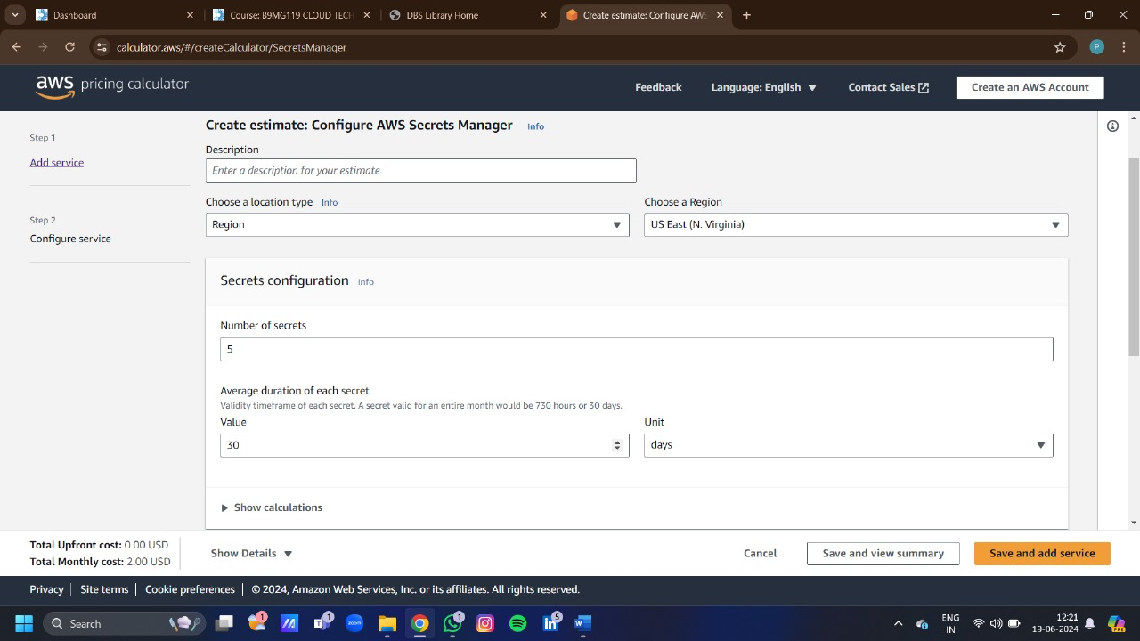

5. \*Amazon ECR\*

- Storage: $1.50 (assuming $0.03 per GB)

- Data transfer: $1 (assuming $0.09 per GB)

- Total: $0.24

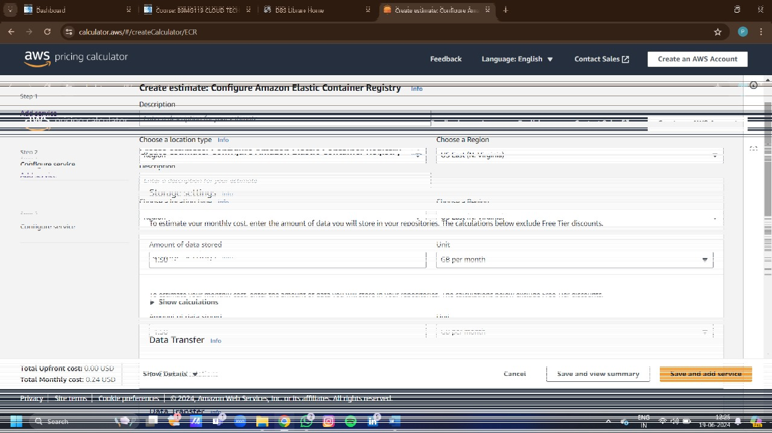

6. \*Amazon API Gateway\*

- API calls: $3.50 (assuming $3.50 per million requests)

- Total: $15.75

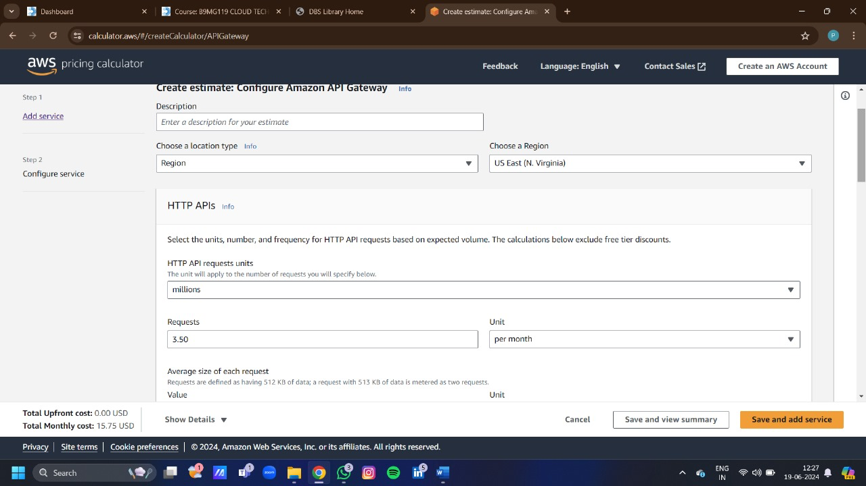

7. \*Amazon Route 53\*

- Hosted zones: $2.50 (assuming $0.50 per hosted zone)

- DNS queries: $0.40 (assuming $0.40 per million queries)

- Total: $2.90

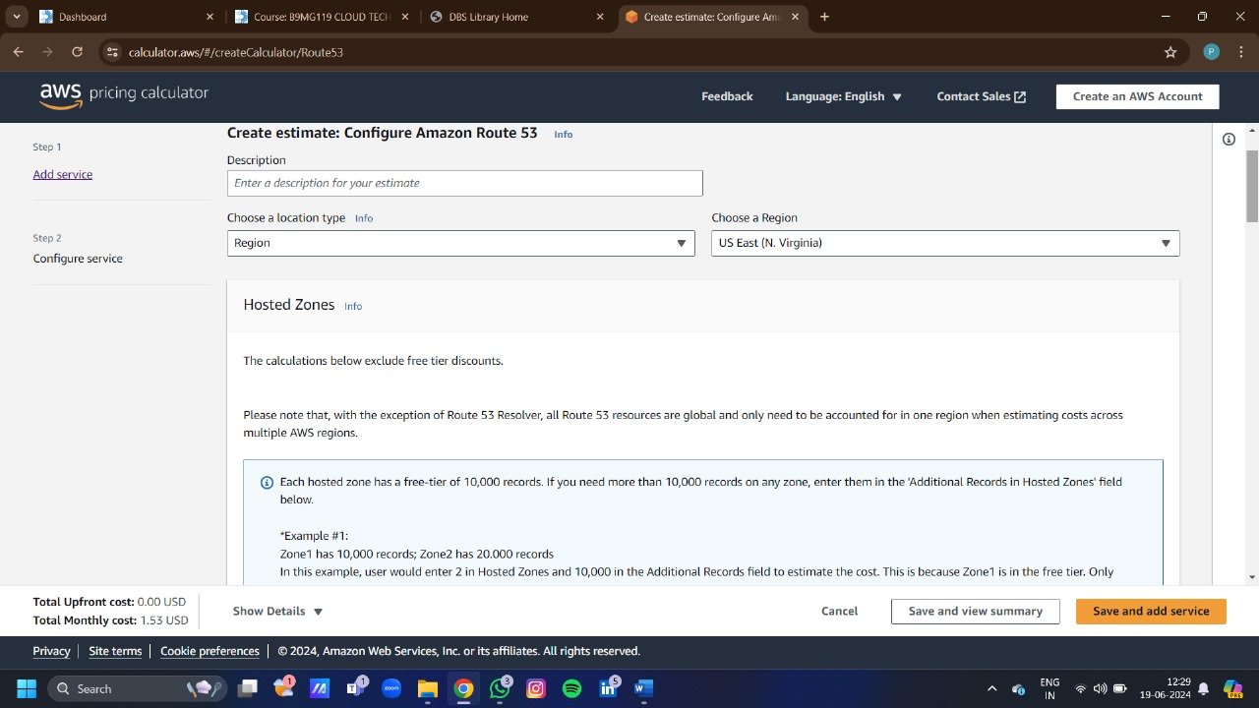

8. \*Amazon CloudWatch\*

- Metrics: $15.00 (assuming $0.30 per metric)

- Logs storage: $0.50 (assuming $0.005 per GB)

- Total: $4.75

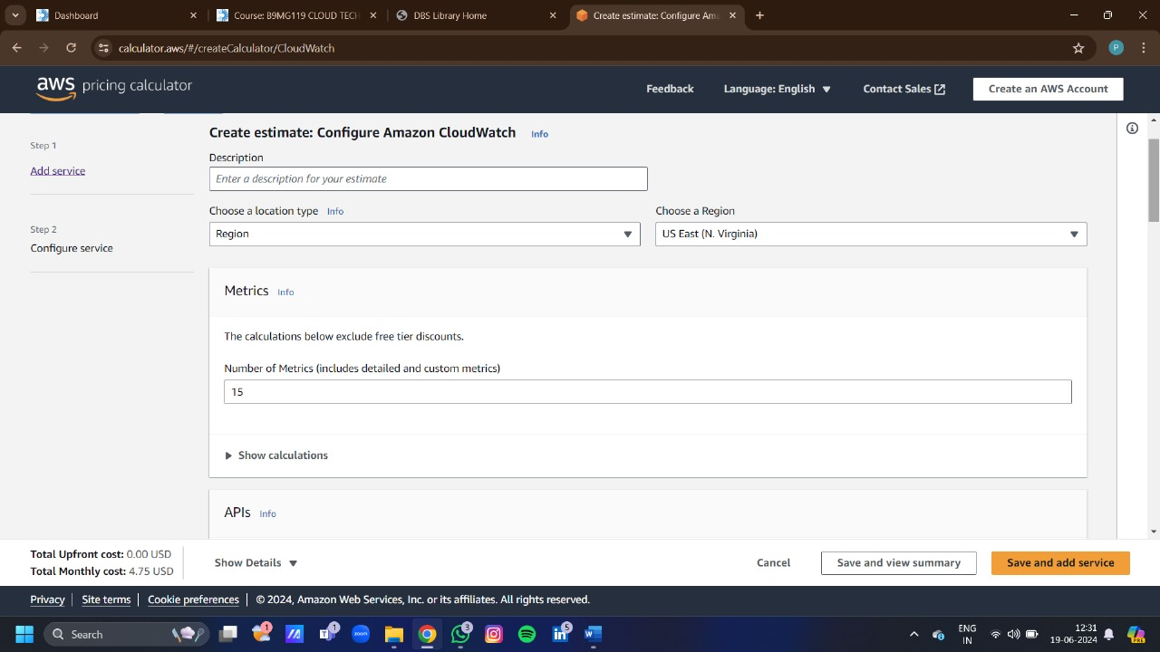

9. \*Amazon GuardDuty\*

- AWS CLOUDTRAIL management event analysis 1 per month

EC2 VPC Flow log analysis 1 per month

EC2 DNS Query log analysis 1 per month

GuardDuty Malware Protection 1 per month

GuardDuty RDS Protection 1 per month

GuardDuty EKS protection 1 per month

GuardDuty Lambda Protection 1 per month

Runtime Protection 1 per month

TOTAL = $8.78

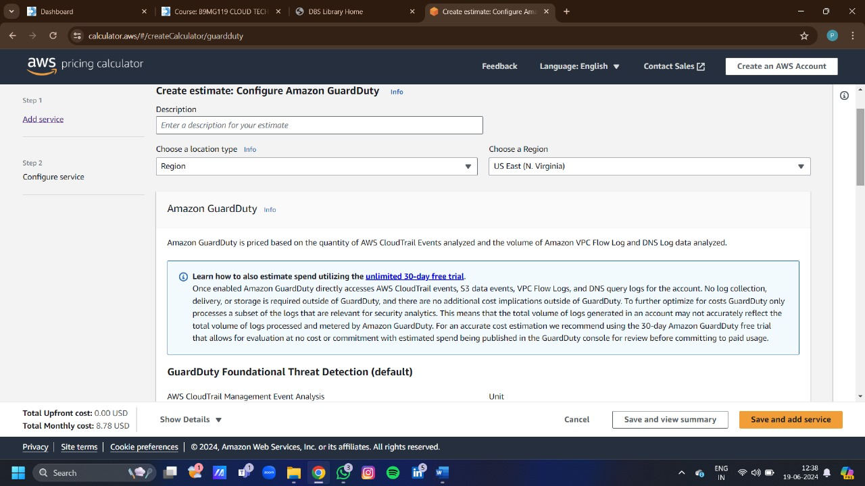

10. \*Amazon SNS\*

- HTTP/HTTPS Notification ( 1 millions. Per month)

EMAIL/EMAIL-JSON Notifications ( 1 millions. Per month)

SQS Notifications( 1 millions. Per month)

Amazon Web Services Lambda( 1 millions. Per month)

Amazon kinesis Data Firehose ( 1 millions. Per month)

TOTAL = $21.21

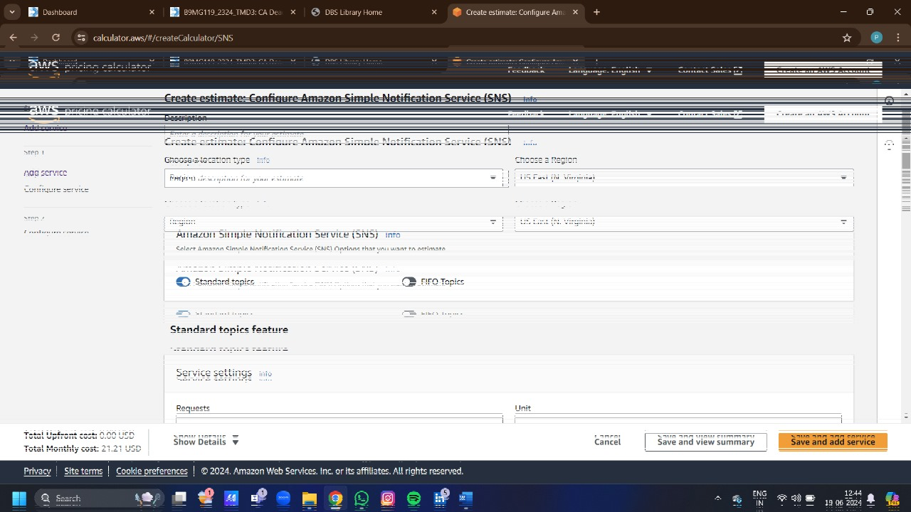

Total Estimated Monthly Cost

Sum of all services:

- Amazon EC2: $7.67

- Amazon RDS: $1.14

- Amazon S3: $0.71

- AWS Secrets Manager: $2.00

- AWS Elastic Beanstalk: NOT FOUND

- Amazon ECR: $0.24

- Amazon API Gateway: $15.75

- Amazon Route 53: $1.53

- Amazon CloudWatch: $4.75

- Amazon GuardDuty: $8.78

- Amazon SNS: $21.21

\*Total: $63.78 per month

TOTAL= 4765.36 Per 12 months

